Project Report
Rhea Bodapati
25BAI11603
CSE AIML
2025-2029
CSA2001: Fundamentals In AIML

Introduction
The 8 Queens problem is a puzzle that requires the player to determine the placement of eight queens on a 8 x 8 chessboard in a manner such that no two queens are able to attack each other; no two queens share the same row, column or diagonal. This problem could have 92 distinct solutions, and it is commonly solved using a backtracking algorithm that places the queens column by column.
Algorithm:
The most common approach is backtracking. It places a queen, checks validity and if a conflict occurs, it backtracks.
- A queen is placed in the first row.
- A queen is placed in a box that is not attacked by the previously placed queens.
- If there isn’t a spot available in a column, return to the previous column to move the last placed queen.
- Repeat until all 8 Queens are placed.

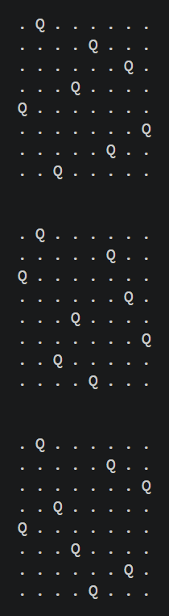
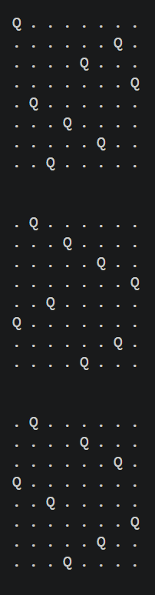
Results:
